LAPORAN PRAKTIK

PRAKTIK BASIS DATA NoSQL MINGGU 2

Abdul Majid (225443001)



1AEC-1
TEKNOLOGI REKAYASA INFORMATIKA INDUSTRI
POLITEKNIK MANUFAKTUR BANDUNG
TAHUN AJARAN 2025/2026
- Deskripsi Studi Kasus
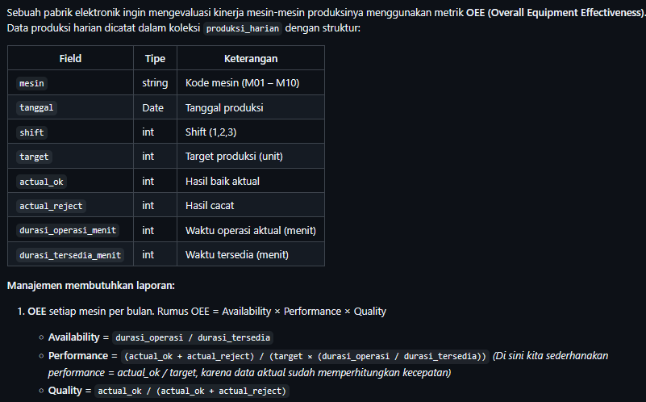
- Persiapan Data

B1. Buat Koleksi dan Generate Data Dummy
from pymongo import MongoClient
from datetime import datetime, timedelta
import random

client = MongoClient('mongodb://localhost:27017')
db = client['studi_kasus_oee']
collection = db['produksi_harian']
collection.drop() # Mulai bersih

mesin_list = [f"M{i:02d}" for i in range(1, 11)]
start_date = datetime(2026, 4, 1)
docs = []

for i in range(1000):
# Acak hari dalam 90 hari
day_offset = random.randint(0, 90)
tanggal = start_date + timedelta(days=day_offset)
shift = random.randint(1, 3)
mesin = random.choice(mesin_list)
target = random.randint(200, 500)
actual_ok = int(target * random.uniform(0.6, 1.0)) # Kadang di bawah target
actual_reject = int(actual_ok * random.uniform(0, 0.15)) # reject sampai 15%
durasi_tersedia = 480 # 8 jam
durasi_operasi = int(durasi_tersedia * random.uniform(0.7, 1.0))

doc = {
"mesin": mesin,
"tanggal": tanggal,
"shift": shift,
"target": target,
"actual_ok": actual_ok,
"actual_reject": actual_reject,
"durasi_operasi_menit": durasi_operasi,
"durasi_tersedia_menit": durasi_tersedia
}
docs.append(doc)

if len(docs) >= 500:
collection.insert_many(docs)
docs.clear()

if docs:
collection.insert_many(docs)

print("Data berhasil dibuat. Total:", collection.count_documents({}))

Output:

Perintah:
use studi_kasus_oee
db.produksi_harian.countDocuments()
db.produksi_harian.findOne()

Output:
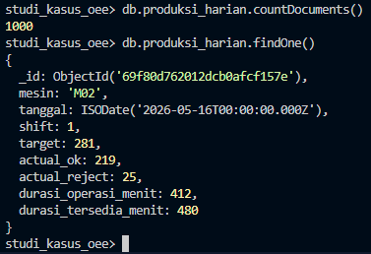

- Menghitung OEE Per Mesin Per Bulan

Perintah:
db.produksi_harian.aggregate([
// Tahap 1: Tidak perlu $match karena ingin semua data
// Tahap 2: Group by mesin dan bulan
{ $group: {
_id: {
mesin: "$mesin",
bulan: { $month: "$tanggal" },
tahun: { $year: "$tanggal" }
},
total_target: { $sum: "$target" },
total_ok: { $sum: "$actual_ok" },
total_reject: { $sum: "$actual_reject" },
total_op: { $sum: "$durasi_operasi_menit" },
total_avail: { $sum: "$durasi_tersedia_menit" }
}},
// Tahap 3: Hitung OEE
{ $project: {
_id: 0,
mesin: "$_id.mesin",
bulan: "$_id.bulan",
tahun: "$_id.tahun",
total_ok: 1,
total_target: 1,
total_reject: 1,
availability: { $divide: ["$total_op", "$total_avail"] },
performance: { $divide: ["$total_ok", "$total_target"] },
quality: { $divide: ["$total_ok", { $add: ["$total_ok", "$total_reject"] } ] },
OEE: {
$multiply: [
{ $divide: ["$total_ok", "$total_target"] },
{ $divide: ["$total_op", "$total_avail"] },
{ $divide: ["$total_ok", { $add: ["$total_ok", "$total_reject"] } ] }
]
}
}},
// Tahap 4: Urutkan berdasarkan OEE terendah
{ $sort: { OEE: 1 } }
])

Output:
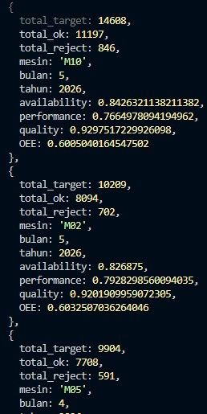

- Menemukan Mesin Dengan OEE

Perintah:
db.produksi_harian.aggregate([
| // Tahap 1: Tidak perlu $match karena ingin semua data
| // Tahap 2: Group by mesin dan bulan
| { $group: {
| _id: {
| mesin: "$mesin",
| bulan: { $month: "$tanggal" },
| tahun: { $year: "$tanggal" }
| },
| total_target: { $sum: "$target" },
| total_ok: { $sum: "$actual_ok" },
| total_reject: { $sum: "$actual_reject" },
| total_op: { $sum: "$durasi_operasi_menit" },
| total_avail: { $sum: "$durasi_tersedia_menit" }
| }},
| // Tahap 3: Hitung OEE
| { $project: {
| _id: 0,
| mesin: "$_id.mesin",
| bulan: "$_id.bulan",
| tahun: "$_id.tahun",
| total_ok: 1,
| total_target: 1,
| total_reject: 1,
| availability: { $divide: ["$total_op", "$total_avail"] },
| performance: { $divide: ["$total_ok", "$total_target"] },
| quality: { $divide: ["$total_ok", { $add: ["$total_ok", "$total_reject"] } ] },
| OEE: {
| $multiply: [
| { $divide: ["$total_ok", "$total_target"] },
| { $divide: ["$total_op", "$total_avail"] },
| { $divide: ["$total_ok", { $add: ["$total_ok", "$total_reject"] } ] }
| ]
| }
| }},
| {$match: {OEE: {$lt: 0.80}}}, {$sort: {OEE: 1}}
| ])

Output:
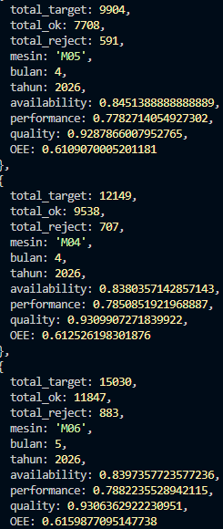

- Distribusi Jumlah Produksi Per Shift Dalam Bucket

Perintah :
db.produksi_harian.aggregate([
| { $bucket: {
| groupBy: "$actual_ok",
| boundaries: [0, 200, 300, 400, 600, 800], // 0-199, 200-299, 300-399, 400-600
| default: "di atas 600",
| output: {
| count: { $sum: 1 },
| rata_reject: { $avg: "$actual_reject" }
| }
| }}
| ])
Output:
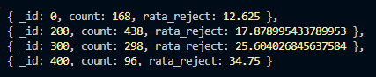

Perintah :
db.produksi_harian.aggregate([
{ $group: {
_id: "$shift",
data: { $push: "$actual_ok" } // kumpulkan nilai
}},
// Kemudian di aplikasi atau gunakan operator $bucket di sub-pipeline (tidak bisa langsung karena $bucket butuh array dokumen)
])

Output :
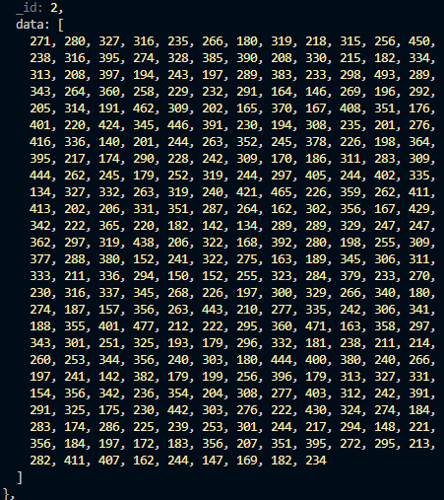

Perintah:
db.produksi_harian.aggregate([
| { $group: { _id: "$shift", total_produksi: { $sum: "$actual_ok" } } }
| ])

Output:
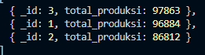

- Optiomasi dan Analisis

db.produksi_harian.createIndex({ mesin: 1, tanggal: 1 })
Output:
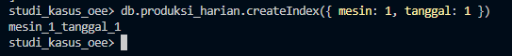

- Latihan Tambahan
- Tren Bulanan
Perintah:
db.produksi_harian.aggregate([
{
$group: {
_id: { $dateToString: { format: "%Y-%m", date: "$tanggal" } },
total_operasi: { $sum: "$durasi_operasi_menit" },
total_tersedia: { $sum: "$durasi_tersedia_menit" },
total_ok: { $sum: "$actual_ok" },
total_reject: { $sum: "$actual_reject" },
total_target: { $sum: "$target" }
}
},
{
$project: {
availability: { $divide: ["$total_operasi", "$total_tersedia"] },
performance: { $divide: [{ $add: ["$total_ok", "$total_reject"] }, "$total_target"] },
quality: { $divide: ["$total_ok", { $add: ["$total_ok", "$total_reject"] }] },
oee: {
$multiply: [
{ $divide: ["$total_operasi", "$total_tersedia"] },
{ $divide: [{ $add: ["$total_ok", "$total_reject"] }, "$total_target"] },
{ $divide: ["$total_ok", { $add: ["$total_ok", "$total_reject"] }] }
]
}
}
},
{
$sort: { _id: 1 }
}
])

Output:
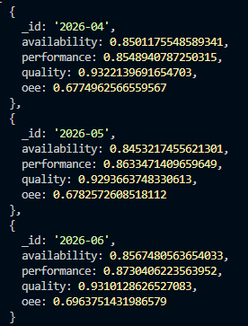
- Mesin Terburuk
Perintah :
db.produksi_harian.aggregate([
{
$match: {
tanggal: {
$gte: ISODate("2026-06-01T00:00:00Z"),
$lt: ISODate("2026-07-01T00:00:00Z")
}
}
},
{
$group: {
_id: "$mesin",
total_operasi: { $sum: "$durasi_operasi_menit" },
total_tersedia: { $sum: "$durasi_tersedia_menit" },
total_ok: { $sum: "$actual_ok" },
total_reject: { $sum: "$actual_reject" },
total_target: { $sum: "$target" }
}
},
{
$project: {
oee: {
$multiply: [
{ $divide: ["$total_operasi", "$total_tersedia"] },
{ $divide: [{ $add: ["$total_ok", "$total_reject"] }, "$total_target"] },
{ $divide: ["$total_ok", { $add: ["$total_ok", "$total_reject"] }] }
]
}
}
},
{
$sort: { oee: 1 }
},
{
$limit: 3
}
])

Output:
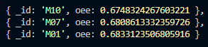
- Kinerja Harian
Perintah:
db.produksi_harian.aggregate([
{
$group: {
_id: {
mesin: "$mesin",
tanggal: { $dateToString: { format: "%Y-%m-%d", date: "$tanggal" } }
},
total_operasi: { $sum: "$durasi_operasi_menit" },
total_tersedia: { $sum: "$durasi_tersedia_menit" },
total_ok: { $sum: "$actual_ok" },
total_reject: { $sum: "$actual_reject" },
total_target: { $sum: "$target" }
}
},
{
$project: {
oee: {
$multiply: [
{ $divide: ["$total_operasi", "$total_tersedia"] },
{ $divide: [{ $add: ["$total_ok", "$total_reject"] }, "$total_target"] },
{ $divide: ["$total_ok", { $add: ["$total_ok", "$total_reject"] }] }
]
}
}
},
{
$sort: { "_id.tanggal": 1, "_id.mesin": 1 }
}
])

Output:
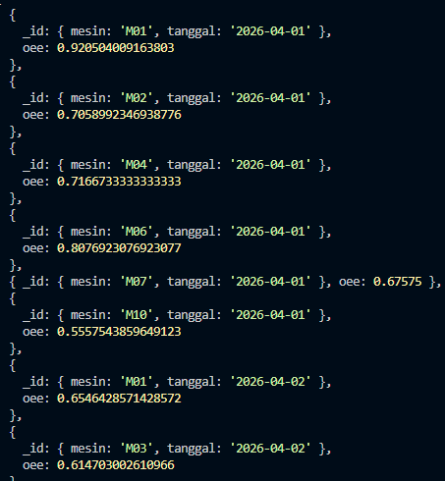
- Simulasi Perbaikan
Perintah:
db.produksi_harian.aggregate([
{
$group: {
_id: "$mesin",
total_ok: { $sum: "$actual_ok" },
total_reject: { $sum: "$actual_reject" }
}
},
{
$project: {
quality: {
$divide: [
"$total_ok",
{ $add: ["$total_ok", "$total_reject"] }
]
}
}
},
{sa
$match: {
quality: { $lt: 0.95 }
}
},
{
$sort: { quality: 1 }
}
])

Output:
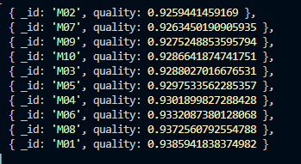
- Penutup
Dengan tutorial ini, Anda telah mempraktikkan:
- $addFields untuk menambah field perhitungan.
- $group dengan akumulator untuk agregat total.
- $praoject untuk kalkulasi metrik bisnis.
- $match untuk filter hasil agregasi.
- $facet untuk multi-pipeline.
- $bucket untuk distribusi.

